# MINOR PROJECT SYNOPSIS

# WEIGHTED TOLL COLLECTION SYSTEM USING RFID



**MARCH - 2017**

**SUBMITTED BY: SUBMITTED TO:**

**SHIVAM SHUKLA (1410) MRS. BHAWNA GUPTA**

**VENICE VARSHNEY (14102229)**

**INTRODUCTION:**

Nowadays, increasing traffic volume causes congestions commonly around the toll gate of highway.

Automated toll collection system is one of the methods to solve the above conditions. The automated system is composed of several subsystems. The RFID technology, computer database, power supply, microcontroller, motor and inferred device are included. The toll amount is deducted from the RFID card. This RFID card is rechargeable and account is stored on the records.

First benefit is that movement of traffic will be much faster as user will not wait to give the money because, driver has to just show the RFID card in-front of the card reader. And then the RFID based automatic gate control system will open the gate to pass through.  
Second benefit is that driver doesn’t have to carry the money each time. He/she will just recharge the RFID card by certain amount and will use this card each time he travels. This is little bit similar to using credit cards.

**COMPONENTS REQUIRED:**

* Radio Frequency Identification (RFID) reader
* RFID card
* LCD
* Buzzer
* Keypad
* DC motor
* IR receiver
* IR LED
* Weighting Platform
* Self Made Arduino:
  + - CH314 Adapter (serial to usb convertor)
    - ATMEGA328P-PU chip (28 pin chip)
    - 16 Mhz Crystal
    - 2 20 pico Farad load capacitors
    - LED
    - 100 nano farad capacitor
    - Bread Board
    - Connecting wires
    - Arduino IDE (software needed)

**WORKING:**

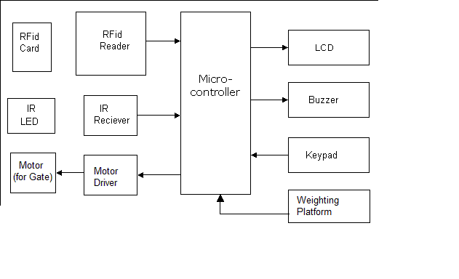

* Receiver: We are going to use an Infrared receiver. It is used to detect that vehicle has passed away from the electronic toll collection plaza.
* Transmitter: Infra-Red transmitters used are IR LEDs. IR rays from transmitters are reflected from the vehicle and are received by the receiver.
* Microcontroller: This is the CPU (central processing unit) of our project. The various functions of Microcontroller are like
  + - Reading the RFID card number from the RFID reader.
    - Sending this data to LCD so that the person operating this project should read various informative messages.
    - Sensing the command given using keypad and receiving signal from the IR receiver.
    - Sending the data to the motor or buzzer depending upon the RFID card number and balance inside the card.
* LCD: Liquid Crystal Display (LCD) which means it can display alphabets along with numbers on 2 lines each containing 16 characters.
* DC motor and Motor Driver: We are going to use a DC motor to open the gate. A motor driver IC is required to drive the motor.
* RFID card reader: This is one of the most important part of the project. It reads the unique number from the RFID cards and sends it to the Microcontroller.
* Weighting Platform: Measures the weight of the vehicle and charges toll accordin



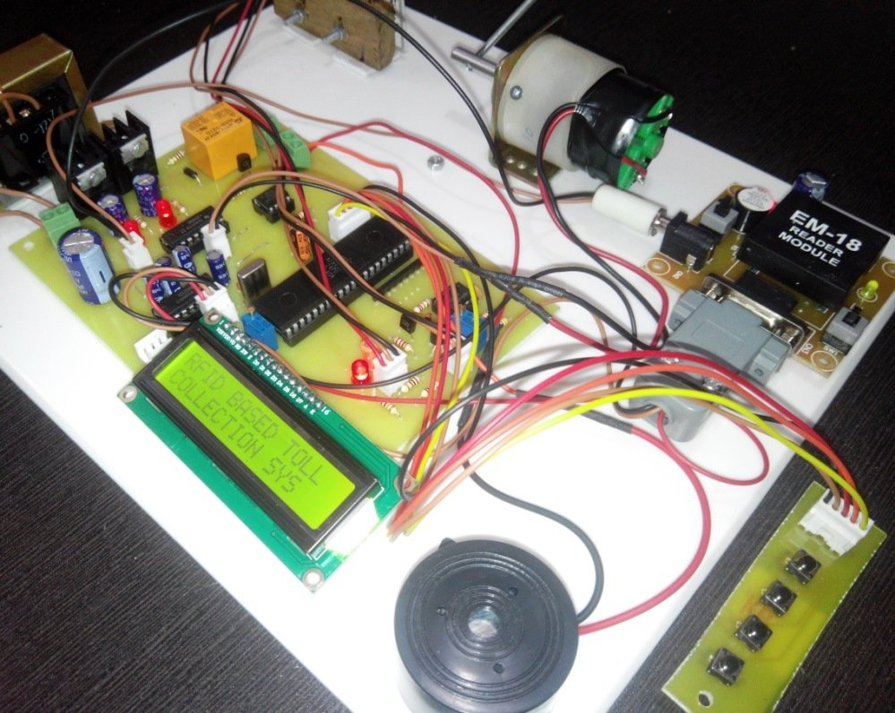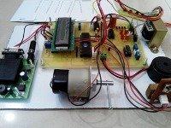

**REFERENCES:**

* Win, AungMyint , Chaw MyatNwe and KyawZinLatt . "RFID Based Automated Toll Plaza System." *International Journal of Scientific and Research Publications.* 4.6 (June 2014): Web.
* Salunke, Pranoti , Poonam Malle, Kirti Datir and Jayshree Dukale. "Automated Toll Collection System Using RFID." *IOSR Journal of Computer Engineering .* 9.2 (Feb 2013): Web.<http://www.iosrjournals.org/iosr-jce/papers/Vol9-Issue2/L0926166.pdf?id=283>.
* Kalantri, Rakhi, Anand Parekar, Akshay Mohite and Rohan Kankapurkar. "RFID Based Toll Collection System ."*International Journal of Computer Science and Information Technologies.* 5.2 (2014): Web.<http://www.ijcsit.com/docs/Volume%205/vol5issue02/ijcsit20140502365.pdf>.